Q1 | Given a CSV file containing Zomato restaurant ratings, use pandas to detect outliers in the 'user_rating' column using the IQR method and print the indices of the detected outliers.
Code | import pandas as pd  df = pd.read_csv("zomato_ratings.csv")  print("Column names:")  print(df.columns)  Q1 = df["rating"].quantile(0.25)  Q3 = df["rating"].quantile(0.75)  IQR = Q3 - Q1  lower_limit = Q1 - 1.5 * IQR  upper_limit = Q3 + 1.5 * IQR  outliers = df[  (df["rating"] < lower_limit) |  (df["rating"] > upper_limit)  ]  print("\nQ1:", Q1)  print("Q3:", Q3)  print("IQR:", IQR)  print("Lower Limit:", lower_limit)  print("Upper Limit:", upper_limit)  print("\nIndices of detected outliers:")  print(outliers.index)
Output | 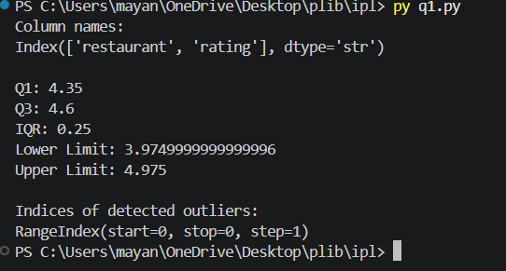

Q2 | Create a boxplot for the 'order_amount' column from a Swiggy orders dataset using matplotlib, and visually identify any outliers present.<br><br><em><strong>Hint:</strong> Use plt.boxplot() and label your axes for clarity.</em>
Code | import pandas as pd  import matplotlib.pyplot as plt  df = pd.read_csv("swiggy_orders.csv")  plt.boxplot(df["order_amount"])  plt.title("Boxplot of Swiggy Order Amount")  plt.xlabel("Swiggy Orders")  plt.ylabel("Order Amount")  plt.show()
Output | 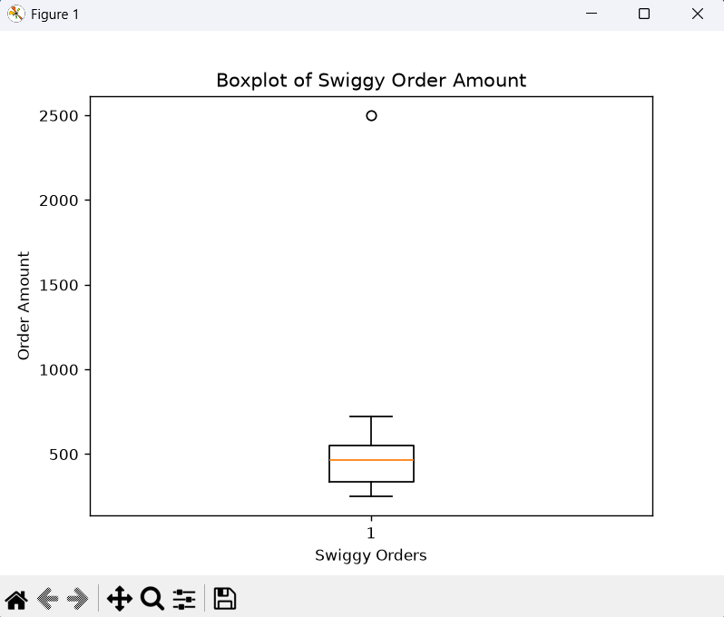

Q3 | Apply winsorization to the 'transaction_amount' column in a Paytm transactions DataFrame to cap all values above the 95th percentile and below the 5th percentile, then display the updated column statistics.
Code | import pandas as pd  df = pd.read_csv("paytm_transactions.csv")  lower_limit = df["transaction_amount"].quantile(0.05)  upper_limit = df["transaction_amount"].quantile(0.95)  print("5th Percentile:", lower_limit)  print("95th Percentile:", upper_limit)  df["transaction_amount"] = df["transaction_amount"].clip(  lower=lower_limit,  upper=upper_limit  )  print("\nUpdated Transaction Amount Statistics:")  print(df["transaction_amount"].describe())
Output | 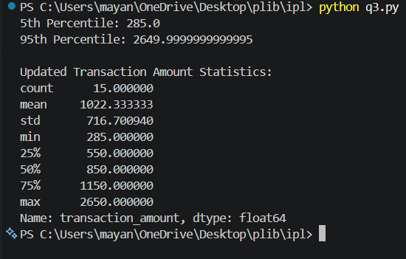

Q4 | You have a DataFrame of Flipkart product prices stored as strings with currency symbols (e.g., '₹1,299'). Convert this column to numeric type using pandas, ensuring all non-numeric characters are removed.<br><br><em><strong>Hint:</strong> Use str.replace() and astype().</em>
Code | import pandas as pd  df = pd.DataFrame({  "product": ["Laptop", "Mobile", "Headphones", "Smartwatch", "Tablet"],  "price": ["₹1,299", "₹25,999", "₹2,499", "₹3,999", "₹15,499"]  })  df["price"] = df["price"].str.replace("₹", "", regex=False)  df["price"] = df["price"].str.replace(",", "", regex=False)  df["price"] = df["price"].astype(int)  print(df)  print("\nData type:")  print(df["price"].dtype)
Output | 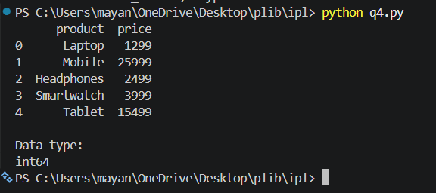

Q5 | Fix the following code snippet where the 'is_premium' column in a Spotify user DataFrame is a mix of boolean, string, and integer types. Convert the entire column to boolean type, treating 'True', 1, and 'yes' as True, and everything else as False.
Code | import pandas as pd  df = pd.DataFrame({  "user": ["Amit", "Riya", "Rahul", "Neha", "Vivek", "Priya"],  "is_premium": [True, "True", 1, "yes", 0, "No"]  })  df["is_premium"] = df["is_premium"].apply(  lambda x: True if str(x).lower() in ["true", "1", "yes"] else False  )  print(df)  print("\nData type:")  print(df["is_premium"].dtype)
Output | 